Peter Julius M. Estacio
Grouped with:
Augusto Gabbriel M. Calilung
Rafael Luis Mari R. Lambo
ENGG 27.01 - M
April 17, 2026

Progress Report 3 for Project 3: Roots of Polynomials

As of April 17, 2026, major progress has been made. The root-finding for each factored polynomial was implemented, accounting for cases when the roots are real and distinct, real and similar, and imaginary and distinct. It also accounts for when Bairstow’s Method deflates to a polynomial of degree 1. Evaluating the original polynomial for each found root was also implemented, accounting for both real and complex roots. All found roots and the function evaluated at that root are output to the console. As such, the program is largely done. Further work then includes outputting the same results to an output file, logic for limiting console output for polynomials with less than 20 roots, more robust user input validation, and overall debugging.

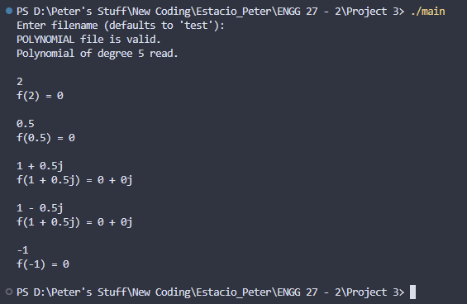
sample screenshot – executable main.exe run and resulting output to console

sample screenshot – compilation on Visual Studio Code

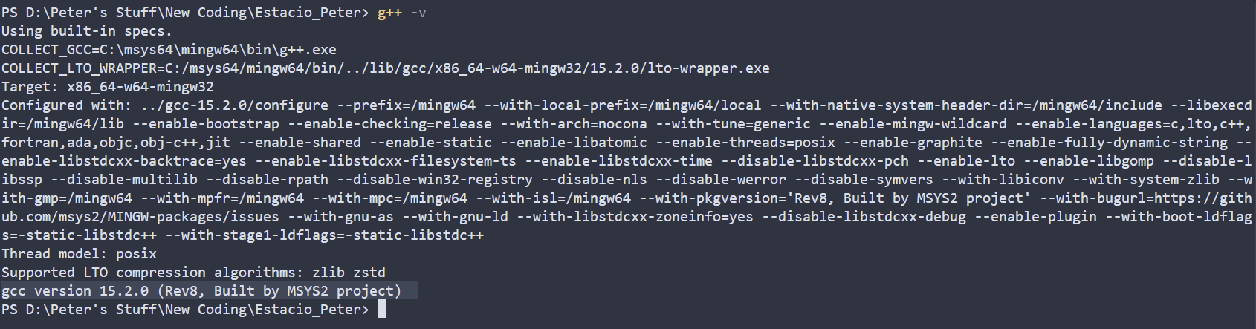
compiler version – gcc version 15.2.0 (Rev8, Built by MSYS2 project)

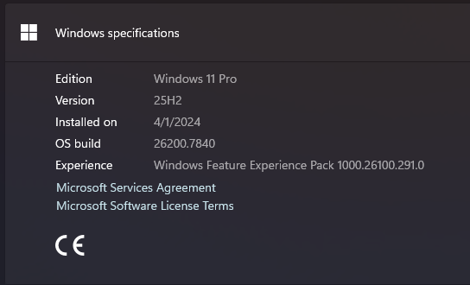
operating system - Windows 11 Pro, 25H2, build 26200.7840

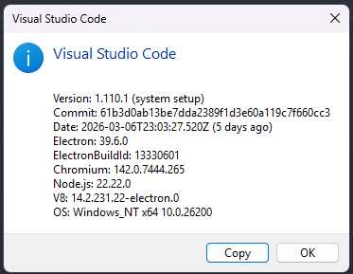
IDE – Visual Studio Code ver 1.110.1

